COMP7025 Social Media Intelligence - Assignment
Namesh Panneer Selvan (22148363)
2026-06-01

Declaration
By including this statement, we the authors of this work, verify that:
• I hold a copy of this assignment that we can produce if the original is lost or damaged.
• I hereby certify that no part of this assignment/product has been copied from any other student’s work or from any other source (including generative sources) except where due acknowledgement is made in the assignment.
• No part of this assignment/product has been written/produced for us by another person except where such collaboration has been authorised by the subject lecturer/tutor concerned.
• I am aware that this work may be reproduced and submitted to plagiarism detection software programs for the purpose of detecting possible plagiarism (which may retain a copy on its database for future plagiarism checking).
• I hereby certify that we have read and understand what the School of Computer, Data and Mathematical Science defines as minor and substantial breaches of misconduct as outlined in the Subject Outline for this unit.

Introduction
The assignment is based around understanding how social media platforms generate huge volumes of engagement data that can be analysed using social network analysis to understand the patterns of connectivity, influence distribution, user engagement. Bluesky is a social media platform that allows users to create, view and follow different types of contents and participate in online communities through hashtags.
The report focuses on Bluesky network which is associated with hastag #WSUCOMP7025. It shows how the data is collected using the Bluesky API and then analysed around six different areas. The objective here is to apply social network analysis to real-world media dataset for understanding the data structure, connectivity, account popularity, etc.

Part 1 - User Gathering

Aim
The section focuses on collecting Bluesky posts containing the hashtag #WSUCOMP7025 and analyse the account creation dates of users who posted this hashtag.

Method
Posts were collected using the bs_search_posts() function from the bskyr package. The downloaded posts were saved as an .rds file so that the same dataset could be reused without repeatedly calling the Bluesky API. Unique author handles were extracted, and each author’s profile was retrieved using bs_get_profile(). The account creation dates were then converted into date format and visualised using a histogram.

Limitation
This analysis only includes users who posted using the hashtag #WSUCOMP7025, the post limit is set to be 100.

Load libraries
library(bskyr)
library(tidyverse)

Login to Bluesky
set_bluesky_user("nameshselvan.bsky.social")
set_bluesky_pass("PASSWORD_HIDDEN")
auth <- bs_auth(
user = bs_get_user(),
pass = bs_get_pass()
)

Search posts with hashtag and save
# Download posts with hashtag
posts <- bs_search_posts("#WSUCOMP7025", limit = 100)
# Save posts data
saveRDS(posts, "posts_data.rds")

Load the saved dataset
posts <- readRDS("posts_data.rds")

Extract author handles only
authors <- tibble(
handle = unique(sapply(posts$author, function(x) x$handle))
)
authors
## # A tibble: 53 × 1
## handle
## <chr>
## 1 22027321.bsky.social
## 2 22076830.bsky.social
## 3 vaibhavbhatia03.bsky.social
## 4 rochakpoudel8.bsky.social
## 5 tahsin8011.bsky.social
## 6 uc-hit.bsky.social
## 7 nishanthapa.bsky.social
## 8 krishnadev1991.bsky.social
## 9 kaliasanya343.bsky.social
## 10 ruchi56.bsky.social
## # ℹ 43 more rows

Get full profile details for each author and save
profiles <- lapply(authors$handle, function(h) {
Sys.sleep(0.5)
bs_get_profile(h)
})
# Save profiles data
saveRDS(profiles, "profiles_data.rds")

Load saved profiles data
profiles <- readRDS("profiles_data.rds")

Extract creation date from profiles
authors$created_at <- sapply(profiles, function(x) x$created_at)
# Convert to date format
authors$created_date <- as.Date(substr(authors$created_at, 1, 10))
authors
## # A tibble: 53 × 3
## handle created_at created_date
## <chr> <chr> <date>
## 1 22027321.bsky.social 2026-05-28T06:43:12.558Z 2026-05-28
## 2 22076830.bsky.social 2026-05-28T01:51:40.965Z 2026-05-28
## 3 vaibhavbhatia03.bsky.social 2026-05-25T02:14:40.961Z 2026-05-25
## 4 rochakpoudel8.bsky.social 2026-05-14T09:20:20.358Z 2026-05-14
## 5 tahsin8011.bsky.social 2026-04-29T09:21:43.757Z 2026-04-29
## 6 uc-hit.bsky.social 2026-05-05T08:18:06.261Z 2026-05-05
## 7 nishanthapa.bsky.social 2026-05-22T03:10:45.556Z 2026-05-22
## 8 krishnadev1991.bsky.social 2026-05-08T01:23:52.258Z 2026-05-08
## 9 kaliasanya343.bsky.social 2026-05-24T08:46:20.961Z 2026-05-24
## 10 ruchi56.bsky.social 2026-05-06T14:41:08.660Z 2026-05-06
## # ℹ 43 more rows

Plot account creation dates
ggplot(authors, aes(x = created_date)) +
geom_bar(fill = "skyblue", color = "black") +
labs(
title = "Account Creation Dates of Users Posting #WSUCOMP7025",
x = "Account Creation Date",
y = "Number of Accounts"
) +
scale_x_date(date_breaks = "1 month", date_labels = "%b %Y") +
theme_minimal() +
theme(axis.text.x = element_text(angle = 45, hjust = 1))
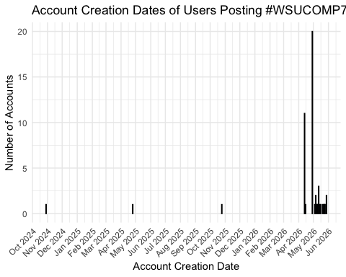

Save graph
ggsave("part1_account_creation_histogram.png", width = 9, height = 5)

Summary for the report
creation_summary <- authors %>%
count(created_date, name = "number_of_accounts") %>%
arrange(created_date)
creation_summary
## # A tibble: 20 × 2
## created_date number_of_accounts
## <date> <int>
## 1 2024-10-29 1
## 2 2025-04-25 1
## 3 2025-10-25 1
## 4 2026-04-13 11
## 5 2026-04-15 1
## 6 2026-04-29 20
## 7 2026-05-04 1
## 8 2026-05-05 1
## 9 2026-05-06 2
## 10 2026-05-08 1
## 11 2026-05-09 1
## 12 2026-05-11 1
## 13 2026-05-12 3
## 14 2026-05-14 1
## 15 2026-05-16 1
## 16 2026-05-20 1
## 17 2026-05-22 1
## 18 2026-05-24 1
## 19 2026-05-25 1
## 20 2026-05-28 2

Interpretation
The histogram indicates that the majority of accounts were created during April and May 2026, with the highest concentration occurring on 29 April 2026, when 20 accounts were registered. This pattern suggests that many users created Bluesky accounts specifically to participate in the COMP7025 activity associated with the hashtag #WSUCOMP7025 The presence of a small number of older accounts indicates that some participants were already active Bluesky users prior to the assignment. Overall, the results suggest that the hashtag successfully encouraged new user adoption while also engaging existing members of the Bluesky community.

Further Analysis
Future research could explore whether newer accounts exhibit different posting behaviours compared with more established accounts. Additional engagement metrics, including likes, reposts, comments and follower counts, could also be analysed to provide a more comprehensive understanding of user activity and participation within the #WSUCOMP7025 community.

Part 2 – Following Graph

Aim
The aim of this section is to construct a directed following graph using the Bluesky users who posted with #WSUCOMP7025 and the accounts they follow.

Method
For each author identified in Part 1, the accounts they follow were retrieved using bs_get_follows(). A directed edge was created from each author to each account they follow. The edge list was saved as an .rds file and then used to construct a directed graph using the igraph package.

Limitation
The following graph only captures publicly visible following relationships at the time of data collection. Private accounts and subsequent changes in following behaviour are not represented.

Load Required Libraries
library(igraph)
library(tidyverse)

Retrieve Following Relationships
# Create empty edge list
edges <- data.frame(
from = character(),
to = character(),
stringsAsFactors = FALSE
)
for(h in authors$handle){
cat("Processing:", h, "\n")
try({
follows <- bs_get_follows(h)
if(nrow(follows) > 0){
temp_edges <- data.frame(
from = h,
to = follows$handle,
stringsAsFactors = FALSE
)
edges <- rbind(edges, temp_edges)
}
Sys.sleep(0.5)
}, silent = TRUE)
}

Save Following Data
saveRDS(edges, "following_data.rds")

Load Following Data
edges <- readRDS("following_data.rds")

Construct Directed Graph
library(igraph)
g <- graph_from_data_frame(
d = edges,
directed = TRUE
)

Graph summary
summary(g)
## IGRAPH 1b4c422 DN-- 264 565 --
## + attr: name (v/c)

Connected Components
comp <- components(g)
summary <- tibble(
Nodes = vcount(g),
Edges = ecount(g),
Components = comp$no,
Largest_Component_Size = max(comp$csize)
)
summary
## # A tibble: 1 × 4
## Nodes Edges Components Largest_Component_Size
## <dbl> <dbl> <dbl> <dbl>
## 1 264 565 1 264

Size of components
comp$csize
## [1] 264

Largest Component
largest_id <- which.max(comp$csize)
largest_nodes <- V(g)[
comp$membership == largest_id
]
largest_graph <- induced_subgraph(
g,
largest_nodes
)

Graph Visualisation
plot(
largest_graph,
vertex.size = 5,
vertex.label = NA,
edge.arrow.size = 0.2,
main = "Largest Connected Component"
)
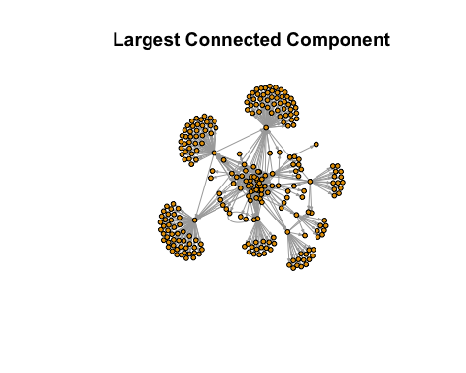

Save graph
png(
"part2_largest_component.png",
width = 1200,
height = 900
)
plot(
largest_graph,
vertex.size = 5,
vertex.label = NA,
edge.arrow.size = 0.2,
main = "Largest Connected Component"
)
dev.off()
## quartz_off_screen
## 2

Interpretation
The following network consisted of 264 nodes and 565 directed edges, representing a moderately connected Bluesky community. Component analysis showed that all nodes belonged to a single connected component, indicating that users were linked either directly or indirectly through following relationships. The network visualisation revealed a dense central core with several peripheral nodes, suggesting the presence of key accounts that facilitate connections across different parts of the network. The existence of a single connected component also implies that information can potentially reach the entire community through the network structure, highlighting a high level of overall connectivity and integration among users.

Further Analysis
Future analysis could explore the presence of subgroups within the network and examine whether users form distinct communities based on their connection patterns and interactions. This may provide additional insights into the overall structure and organisation of the Bluesky network.

Part 3 – Graph Statistics

Aim
The aim of this section is to analyse the structural properties of the largest connected component of the Bluesky following network. Network statistics including diameter, density, degree distribution and power law coefficient are calculated to understand the connectivity and complexity of the network.

Method
The largest connected component identified in Part 2 was converted into an undirected graph. Several network statistics were then calculated using the igraph package, including graph diameter, density, degree distribution and power law coefficient.

Limitation
The graph statistics are calculated from a single snapshot of the network and may change as users create or remove following relationships.

Convert to Undirected Graph
# Convert largest component to undirected graph
largest_graph_undirected <- as_undirected(largest_graph, mode = "collapse")

Calculate Diameter
diameter_value <- diameter(
largest_graph_undirected
)
diameter_value
## [1] 5

Calculate Density
density_value <- edge_density(
largest_graph_undirected
)
density_value
## [1] 0.01471944

Degree Distribution
degree_values <- degree(
largest_graph_undirected
)

Log-log degree distribution plot
degree_table <- as.data.frame(table(degree_values))
colnames(degree_table) <- c("Degree", "Frequency")
degree_table$Degree <- as.numeric(as.character(degree_table$Degree))
degree_table$Frequency <- as.numeric(degree_table$Frequency)
degree_table <- degree_table[
degree_table$Degree > 0 & degree_table$Frequency > 0,
]
ggplot(degree_table, aes(x = Degree, y = Frequency)) +
geom_point() +
scale_x_log10() +
scale_y_log10() +
labs(
title = "Log-Log Degree Distribution",
x = "Degree (log scale)",
y = "Frequency (log scale)"
) +
theme_minimal()
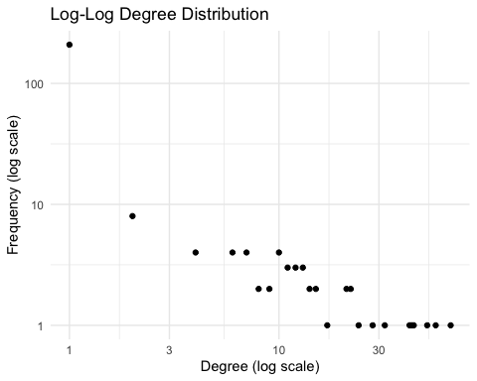
ggsave("part3_loglog_degree_distribution.png", width = 8, height = 5)

Plot Degree Distribution
hist(
degree_values,
main = "Degree Distribution",
xlab = "Degree",
ylab = "Frequency",
col = "skyblue"
)
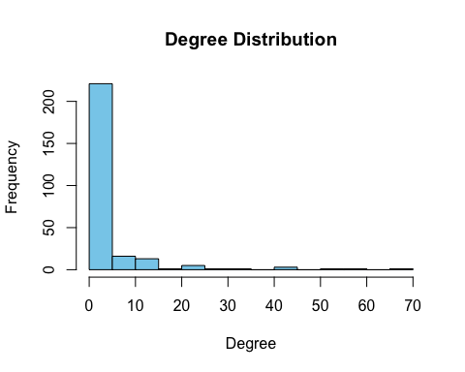

Save graph
png(
"part3_degree_distribution.png",
width = 1000,
height = 800
)
hist(
degree_values,
main = "Degree Distribution",
xlab = "Degree",
ylab = "Frequency",
col = "skyblue"
)
dev.off()
## quartz_off_screen
## 2

Power Law Coefficient
power_law <- fit_power_law(
degree_values + 1
)
power_law
## $continuous
## [1] FALSE
##
## $alpha
## [1] 2.444177
##
## $xmin
## [1] 10
##
## $logLik
## [1] -118.1047
##
## $KS.stat
## [1] 0.08612004

Extracting alpha
alpha_value <- power_law$alpha
alpha_value
## [1] 2.444177

Summary table
graph_statistics <- data.frame(
Metric = c("Diameter", "Density", "Power Law Alpha"),
Value = round(c(diameter_value, density_value, alpha_value), 4)
)
graph_statistics
## Metric Value
## 1 Diameter 5.0000
## 2 Density 0.0147
## 3 Power Law Alpha 2.4442

Interpretation
The largest connected component was converted into an undirected network for statistical analysis. The network diameter was 5, meaning the longest shortest path between any two nodes is five steps. The density was 0.0147, showing that only a small proportion of all possible connections are present. This suggests the network is sparse, which is common in social networks where users connect selectively. The degree distribution is skewed, with most accounts having few connections and a small number having many connections. The estimated power law coefficient was 2.4442. This value falls within the range commonly observed in scale-free networks and suggests that a small number of highly connected hub accounts dominate connectivity while most users maintain relatively few connections.

Further Analysis
Future analysis could further explore how users are connected within the network and identify patterns that may provide a deeper understanding of user interactions, influence, and the overall structure of the Bluesky community.

Part 4 - Investigating Homophily

Aim
The aim of this section is to test whether accounts with the same handle suffix are more likely to be connected in the Bluesky following graph.

Method
The suffix of each account handle was extracted and added as a vertex attribute. Homophily was tested by comparing connected accounts with the same suffix against connected accounts with different suffixes.

Extract suffix from handle
get_suffix <- function(handle) {
parts <- strsplit(handle, "\\.")[[1]]
paste0(".", tail(parts, 1))
}
V(largest_graph_undirected)$suffix <- sapply(
V(largest_graph_undirected)$name,
get_suffix
)

Check suffix distribution
suffix_table <- table(V(largest_graph_undirected)$suffix)
suffix_table
##
## .ai .app .blog .ca .co .com
## 1 1 1 2 2 52
## .fr .io .love .net .org .phd
## 1 3 1 3 12 1
## .photography .rs .social .us .xyz
## 1 1 180 1 1

Get edge list from undirected graph
edge_list <- as_data_frame(
largest_graph_undirected,
what = "edges"
)

Add suffix of from and to nodes
edge_list$from_suffix <- V(largest_graph_undirected)$suffix[
match(edge_list$from, V(largest_graph_undirected)$name)
]
edge_list$to_suffix <- V(largest_graph_undirected)$suffix[
match(edge_list$to, V(largest_graph_undirected)$name)
]
# Check whether both ends have same suffix
edge_list$same_suffix <- edge_list$from_suffix == edge_list$to_suffix
suffix_factor <- as.factor(V(largest_graph_undirected)$suffix)
assortativity_result <- assortativity_nominal(
largest_graph_undirected,
types = as.integer(suffix_factor),
directed = FALSE
)
assortativity_result
## [1] 0.02676216
#The assortativity coefficient was 0.0268. Although positive, the value is relatively small, indicating weak homophily based on account suffix. This suggests that while users show some tendency to connect with accounts sharing the same suffix, cross-suffix connections remain common.

Count same suffix vs different suffix links
homophily_table <- table(edge_list$same_suffix)
homophily_table
##
## FALSE TRUE
## 165 346

Proportion of same suffix links
same_suffix_proportion <- mean(edge_list$same_suffix)
same_suffix_proportion
## [1] 0.6771037
# Expected same-suffix proportion under random mixing
suffix_counts <- table(V(largest_graph_undirected)$suffix)
suffix_prob <- suffix_counts / sum(suffix_counts)
expected_same_suffix <- sum(suffix_prob^2)
homophily_comparison <- data.frame(
Metric = c(
"Observed same-suffix proportion",
"Expected same-suffix proportion under random mixing"
),
Value = round(c(same_suffix_proportion, expected_same_suffix), 4)
)
homophily_comparison
## Metric Value
## 1 Observed same-suffix proportion 0.6771
## 2 Expected same-suffix proportion under random mixing 0.5063
# Summary
homophily_summary <- data.frame(
Metric = c("Same Suffix Links", "Different Suffix Links", "Same Suffix Percentage"),
Value = c(
sum(edge_list$same_suffix),
sum(!edge_list$same_suffix),
round(mean(edge_list$same_suffix) * 100, 1)
)
)
homophily_summary
## Metric Value
## 1 Same Suffix Links 346.0
## 2 Different Suffix Links 165.0
## 3 Same Suffix Percentage 67.7

Mixing matrix by suffix
mixing_matrix <- table(
edge_list$from_suffix,
edge_list$to_suffix
)
mixing_matrix
##
## .ai .app .blog .ca .co .com .fr .io .love .net .org .phd .photography
## .org 0 0 0 0 1 12 0 1 0 0 7 0 0
## .social 1 44 1 2 1 41 1 2 1 3 20 1 1
##
## .rs .social .us .xyz
## .org 0 29 0 0
## .social 1 339 1 1

Optional: plot suffix distribution
barplot(
suffix_table,
main = "Distribution of Account Handle Suffixes",
xlab = "Handle Suffix",
ylab = "Number of Accounts",
las = 2
)
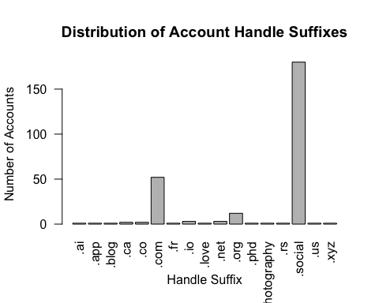
png(
"part4_suffix_distribution.png",
width = 1000,
height = 800
)
barplot(
suffix_table,
main = "Distribution of Account Handle Suffixes",
xlab = "Handle Suffix",
ylab = "Number of Accounts",
las = 2
)
dev.off()
## quartz_off_screen
## 2

Interpretation
The observed same-suffix connection rate was 67.7%. However, because .social accounts made up the majority of the network, a high same-suffix rate could occur naturally under random mixing. Therefore, the observed value was compared with the expected same-suffix proportion under random mixing. The assortativity coefficient was positive but small, indicating that suffix-based homophily exists only weakly. Overall, the result provides limited evidence of homophily, while also showing that many connections occur across different suffix groups.

Further Analysis
Future work could investigate whether homophily also exists with respect to account age, posting frequency or content type.

Part 5 – Account Popularity

Aim
The aim of this section is to measure the popularity of Bluesky accounts using the Scaled PageRank algorithm. The ten most popular accounts are identified and their PageRank scores are compared with their network degree.

Method
PageRank was calculated on the largest component of the Bluesky network using a damping factor of α = 0.8. The resulting PageRank scores were used to rank accounts according to their importance in the network. Degree values were then compared against PageRank scores to investigate whether highly connected accounts were also highly influential.

Limitation
PageRank was calculated using a static network snapshot and does not account for future changes in user relationships.

Calculate PageRank
pagerank_result <- page_rank(
largest_graph,
damping = 0.8
)

Extract PageRank Scores
pagerank_scores <- data.frame(
Account = names(pagerank_result$vector),
PageRank = pagerank_result$vector
)

Calculate Degree
degree_scores <- degree(largest_graph)
degree_df <- data.frame(Account = names(degree_scores), Degree = degree_scores)

Combine Results
popularity_df <- merge(
pagerank_scores,
degree_df,
by = "Account"
)

Top 10 Most Popular Accounts
top10_accounts <- popularity_df %>%
arrange(desc(PageRank)) %>%
slice(1:10) %>%
mutate(PageRank = round(PageRank, 4))
top10_accounts
## Account PageRank Degree
## 1 bsky.app 0.0645 44
## 2 ashishtiwari2410.bsky.social 0.0211 11
## 3 krishnadev1991.bsky.social 0.0198 2
## 4 lapark.mldm.org 0.0101 66
## 5 nelsonamanjr.bsky.social 0.0082 24
## 6 nameshselvan.bsky.social 0.0080 13
## 7 general-haejin.bsky.social 0.0077 20
## 8 22028269.bsky.social 0.0076 31
## 9 jmalhotra1402.bsky.social 0.0070 11
## 10 tiffany123456.bsky.social 0.0070 42
# Save the table
write.csv(
top10_accounts,
"part5_top10_accounts.csv",
row.names = FALSE
)

Visualise Top 10 Accounts
library(ggplot2)
ggplot(
top10_accounts,
aes(
x = reorder(Account, PageRank),
y = PageRank
)
) +
geom_col(fill = "steelblue") +
coord_flip() +
labs(
title = "Top 10 Accounts by PageRank",
x = "Account",
y = "PageRank Score"
) +
theme_minimal()
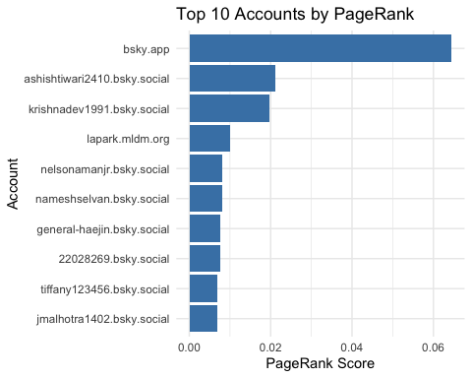
# Save plot
ggsave(
"part5_pagerank_top10.png",
width = 10,
height = 6
)

Correlation Between Degree and PageRank
correlation <- round(
cor(popularity_df$Degree, popularity_df$PageRank),
4
)
correlation
## [1] 0.4139
#The correlation coefficient of 0.4139 indicates a moderate positive relationship between degree and PageRank. Accounts with more connections tend to be influential, but influence is also affected by the quality of those connections.

Interpretation
PageRank was used to evaluate the influence of accounts within the Bluesky network. The highest PageRank score observed was 0.0643, indicating the presence of highly influential accounts within the community. The correlation between degree and PageRank was 0.4139, suggesting a moderate positive relationship between the number of connections and overall influence. However, the results indicate that influence is not determined solely by the quantity of connections but also by the importance of the accounts providing those connections. Consequently, PageRank offers a more comprehensive measure of influence than degree alone.

Further Analysis
Future analysis could explore additional approaches for identifying influential users and compare the results to gain a broader understanding of how influence is distributed across the Bluesky network.

Part 6 - Account Selection

Aim
The aim of this section is to determine the mixed-strategy Nash Equilibrium for .social and .com accounts when choosing between Advertising and Information posts.

Method
The payoff matrix provided in the assignment is used to calculate the mixed-strategy Nash Equilibrium.
Let:
p = probability that .com accounts choose Advertising 1−p = probability that .com accounts choose Information q = probability that .social accounts choose Advertising 1−q = probability that .social accounts choose Information
At equilibrium, each player must be indifferent between their available strategies.

Limitation
The analysis assumes that account behaviour is influenced solely by the payoff matrix and does not consider external factors such as user preferences or platform incentives.

Payoff Matrix
payoff_matrix <- matrix(
c("0.9, 0.7", "0.4, 0.3",
"0.2, 0.2", "0.6, 0.6"),
nrow = 2,
byrow = TRUE
)
rownames(payoff_matrix) <- c(".social Advertising", ".social Information")
colnames(payoff_matrix) <- c(".com Advertising", ".com Information")
payoff_matrix
## .com Advertising .com Information
## .social Advertising "0.9, 0.7" "0.4, 0.3"
## .social Information "0.2, 0.2" "0.6, 0.6"

Solve for q (.social Advertising Probability)
q <- (0.6 - 0.2) /
(0.9 - 0.2 - 0.4 + 0.6)
q
## [1] 0.4444444

Solve for p (.com Advertising Probability)
p <- (0.6 - 0.3) /
(0.7 - 0.3 - 0.2 + 0.6)
p
## [1] 0.375

Equilibrium Results
equilibrium <- data.frame(
Account_Type = c(".com", ".social"),
Advertising = round(c(p, q), 4),
Information = round(c(1 - p, 1 - q), 4)
)
equilibrium
## Account_Type Advertising Information
## 1 .com 0.3750 0.6250
## 2 .social 0.4444 0.5556

Visualisation
library(tidyr)
library(ggplot2)
equilibrium_long <- pivot_longer(
equilibrium,
cols = c(Advertising, Information),
names_to = "Strategy",
values_to = "Probability"
)
ggplot(
equilibrium_long,
aes(
x = Account_Type,
y = Probability,
fill = Strategy
)
) +
geom_col(position = "dodge") +
labs(
title = "Mixed Strategy Nash Equilibrium",
x = "Account Type",
y = "Probability"
) +
theme_minimal()
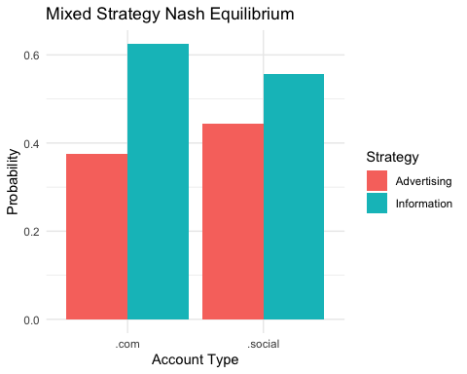

Interpretation
The mixed-strategy Nash Equilibrium suggests that .com accounts should choose Advertising with a probability of 0.375 and Information with a probability of 0.625, while .social accounts should choose Advertising with a probability of 0.4444 and Information with a probability of 0.5556. These results indicate that neither account type can improve its expected outcome by changing its strategy independently. Overall, the findings suggest that a balanced approach to advertising and information sharing is more beneficial than relying heavily on a single content strategy, contributing to a more diverse and engaging network environment.

Further Analysis
Future analysis could explore how different assumptions or conditions influence user behaviour and whether alternative content-sharing patterns emerge within the network.

Conclusion
This report examined the Bluesky network associated with #WSUCOMP7025 using a range of social network analysis techniques. The findings showed that many accounts were created recently, the network was highly connected through a single main component, and user connections exhibited characteristics commonly observed in social media networks. The analysis also identified patterns in user interactions, highlighted influential accounts within the network, and explored content-sharing behaviour through a game-theoretic perspective. Overall, the results provide valuable insights into the structure, connectivity, and behaviour of users within the Bluesky community, demonstrating the practical application of social network analysis to real-world social media data.

